Welcome to Skills Network Labs, previously known as Data Scientist Workbench or BDU Labs. It's a free virtual lab environment that lets you practice your skills in Python, R, and more, while you learn data science.

Skills Network Labs is an environment that contains tools such as RStudio, Jupyter Notebook, and Zeppelin Notebook. These tools provides an interactive environment for you to perform data analysis, data visualization, machine learning and image recognition. For example, on Jupyter Notebook you can train a model that can recognize the denomination of an Euro banknote by using just the image of the banknote.

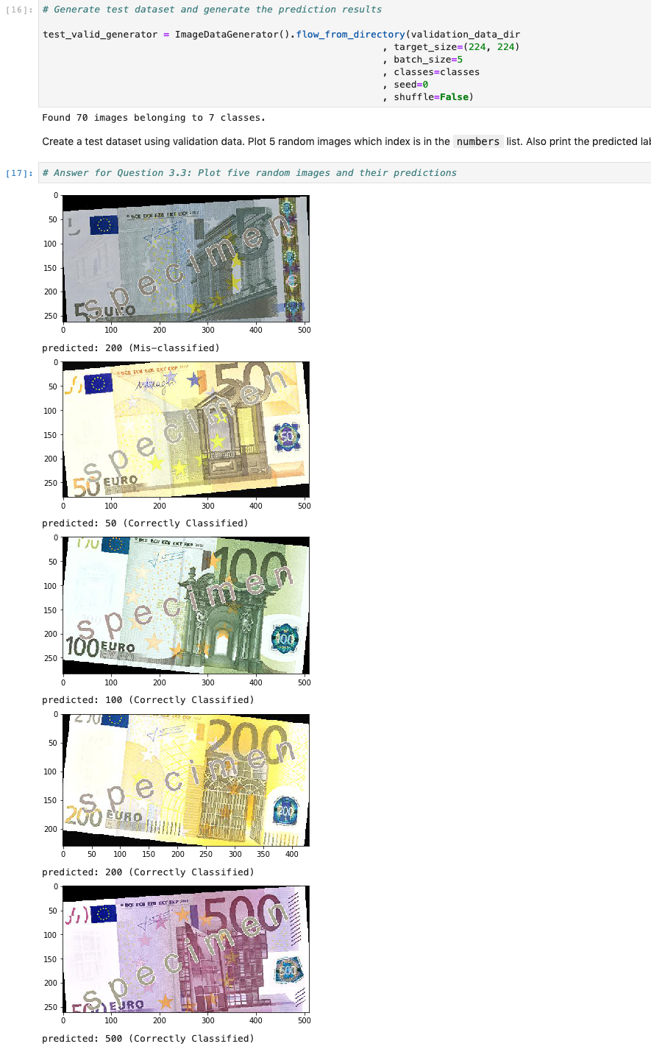

It's ready to use in your web browser. So without having to install anything on your computer, you can immediately start using popular data science tools like RStudio IDE, Jupyter Notebooks, Apache Zeppelin and more. In these videos, you'll be learning about these popular tools and how to get familiar working in the environments. Skills Network Labs is also the virtual lab environment for [cognitiveclass.ai](https://cognitiveclass.ai/), a popular website with lots of free online courses in data science, artificial intelligence, and data engineering. But throughout these videos, you'll also hear us referring to Data Scientist Workbench, which is simply the former name of Skills Network Labs. So in actuality, Skills Network Labs and Data Scientist Workbench are one and the same. Let's first go through some of the user interface on Skills Network Labs shown in the image below to get you familiarized with the environment before jumping into the data science tools.

